This document provides the steps to create SSIS package that can load CSV data into Database table.

Please find the steps below:

1. Create SSIS Project.
2. Create Flat File connection.

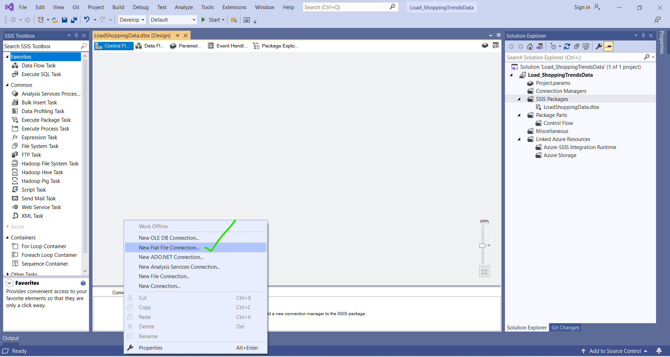

1. Name the connection and click Browse and select the file to load.

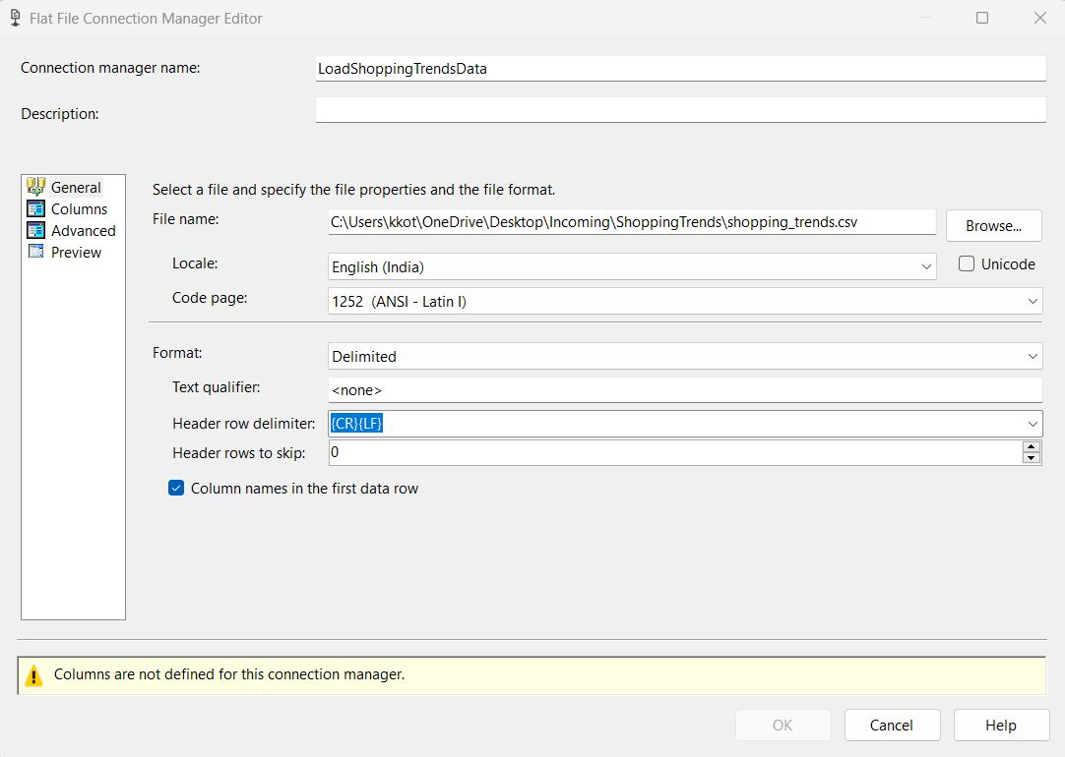

1. Click on Columns and Click OK

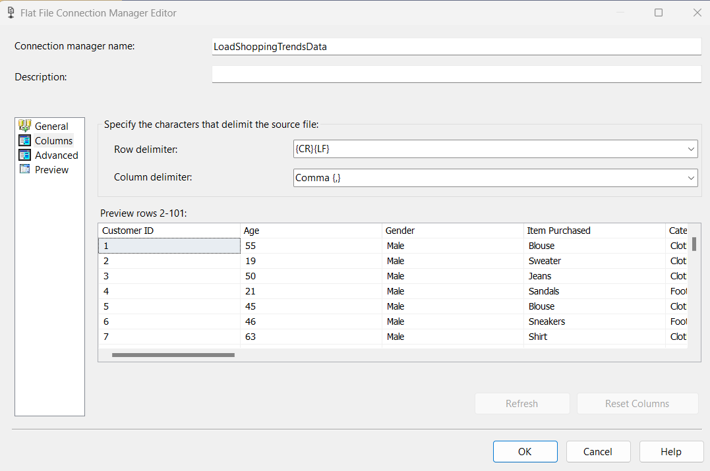

1. Now let’s create Database connection to load data into its DB table.
2. Create OLE DB connection.

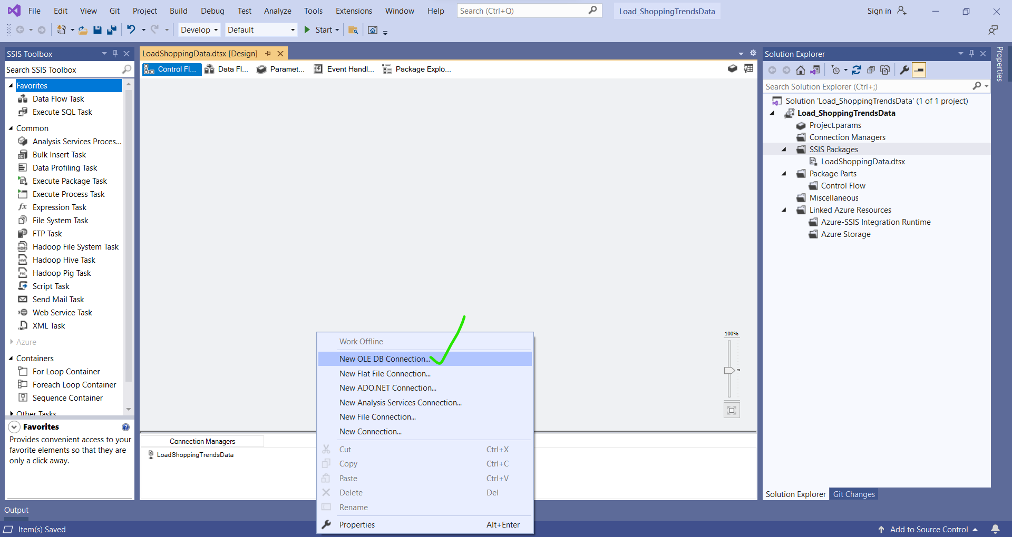

1. Click New, enter Server Name, select Database.
2. Test the connection.
3. Click OK

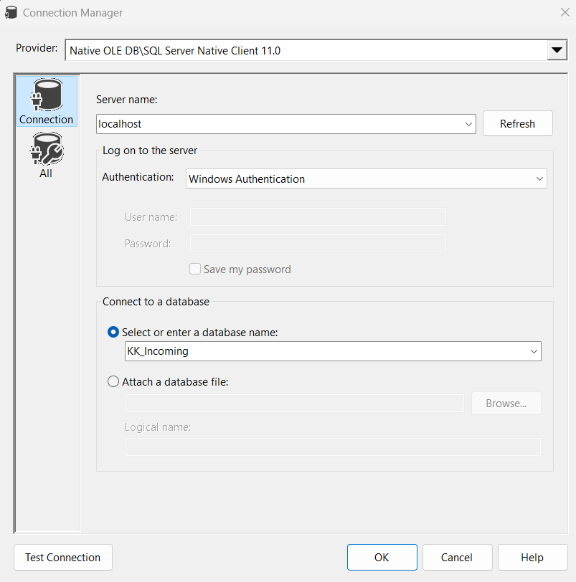

1. Now you will see both file connection and DB server connection are created.
2. As we are done with connection part. Lets create the Package to load the data.
3. From SSIS Toolbox, drag and drop Data Flow Task on to Control Flow tab.

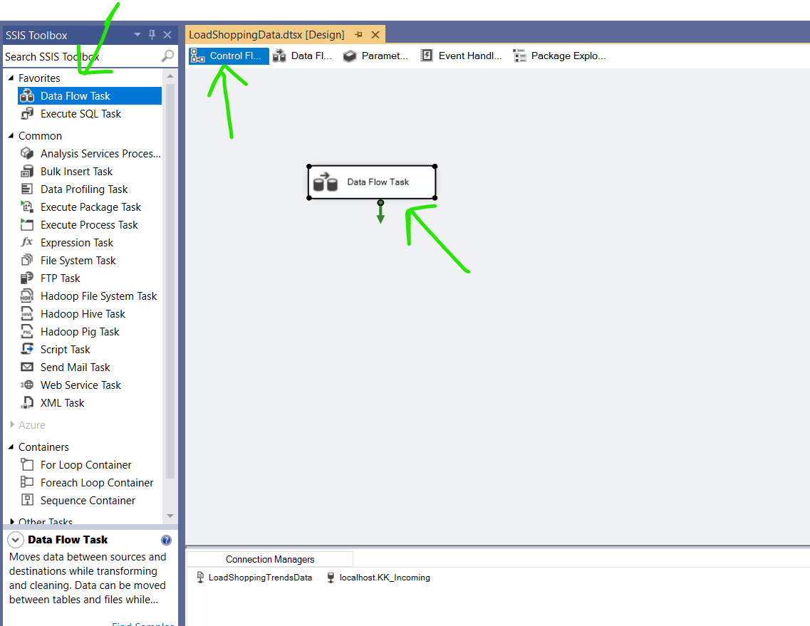

1. Double click on Data Flow Task.
2. Drag and drop Flat File Source from SSIS Toolbox.

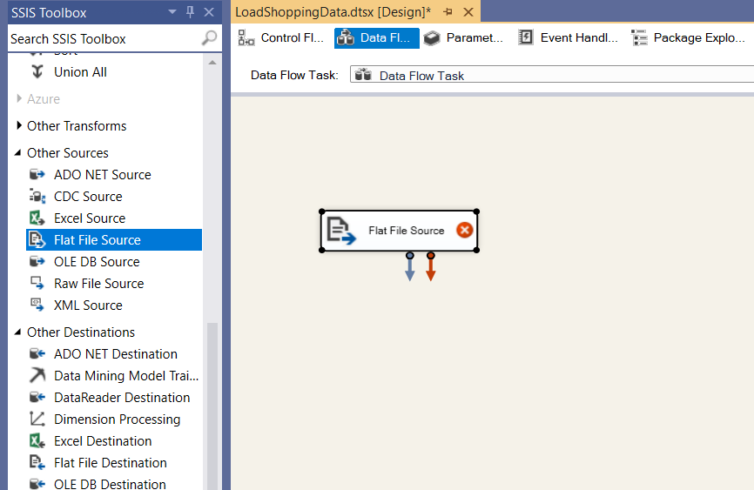

1. Double click on Flat File Source and configure.
2. Select the file connection create earlier as Flat File connection manager
3. Click OK

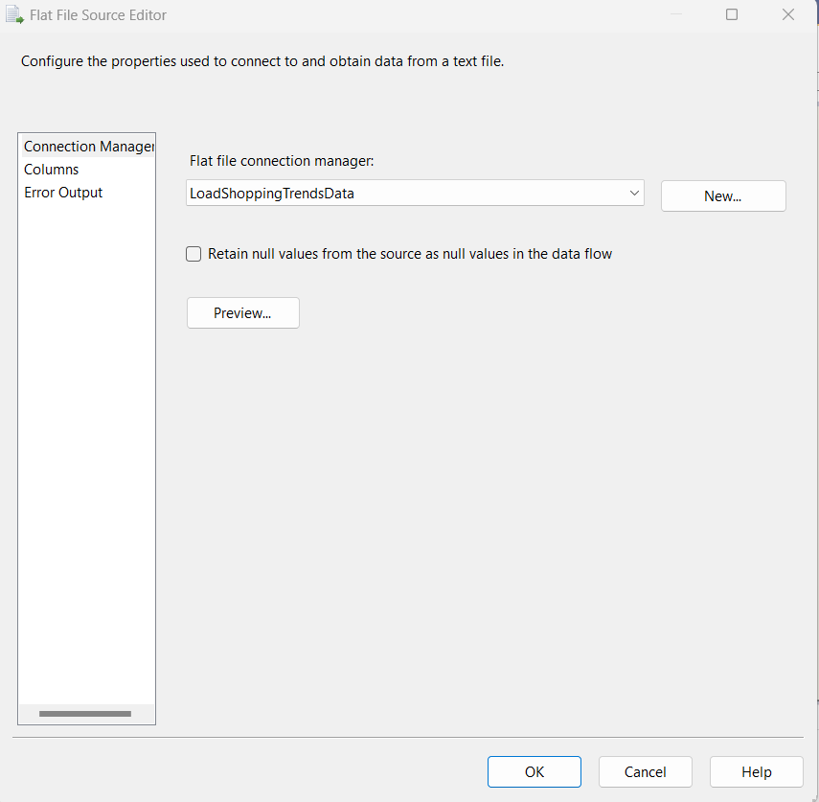

1. Now drag and drop OLE DB Destination from SSIS Toolbox.
2. Connect Flat File Source to OLE DB Destination.

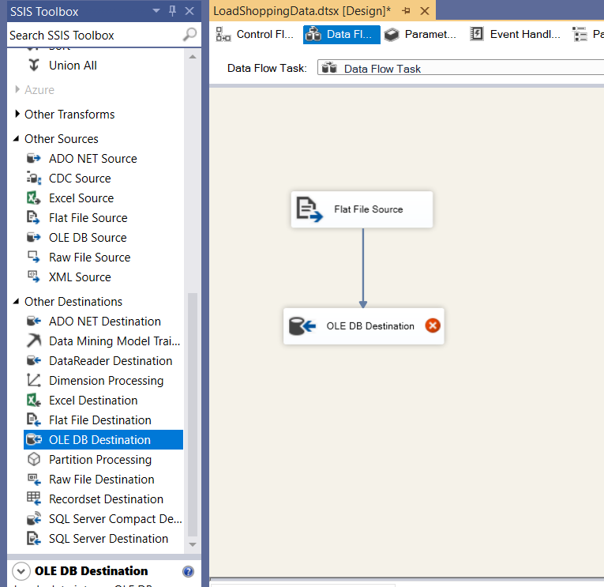

1. Now double click on OLE DB Destination and select the server, db and table to load this file data.

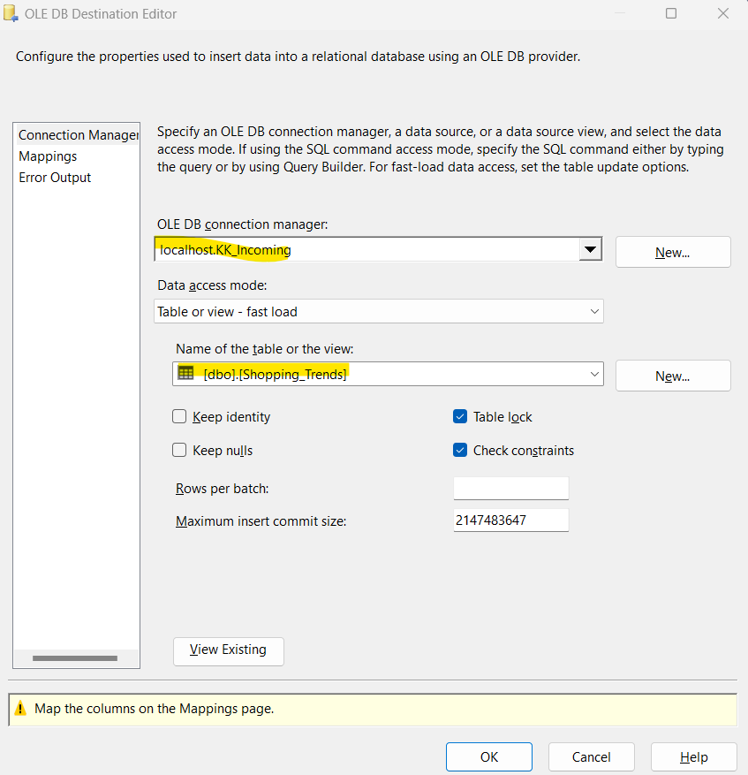

1. Click on Mappings and click OK
2. Now we are all set to execute the package.
3. Go to Control Flow tab.
4. Click on Start button.

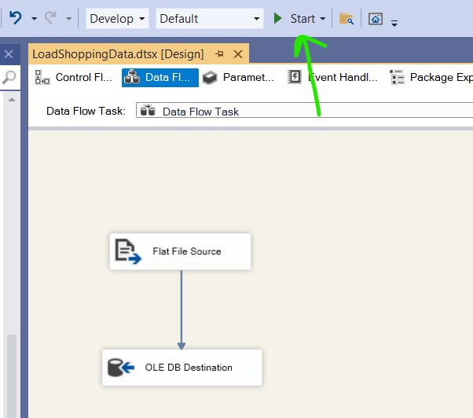

1. Package executed successfully and shows the no. of rows loaded into table.

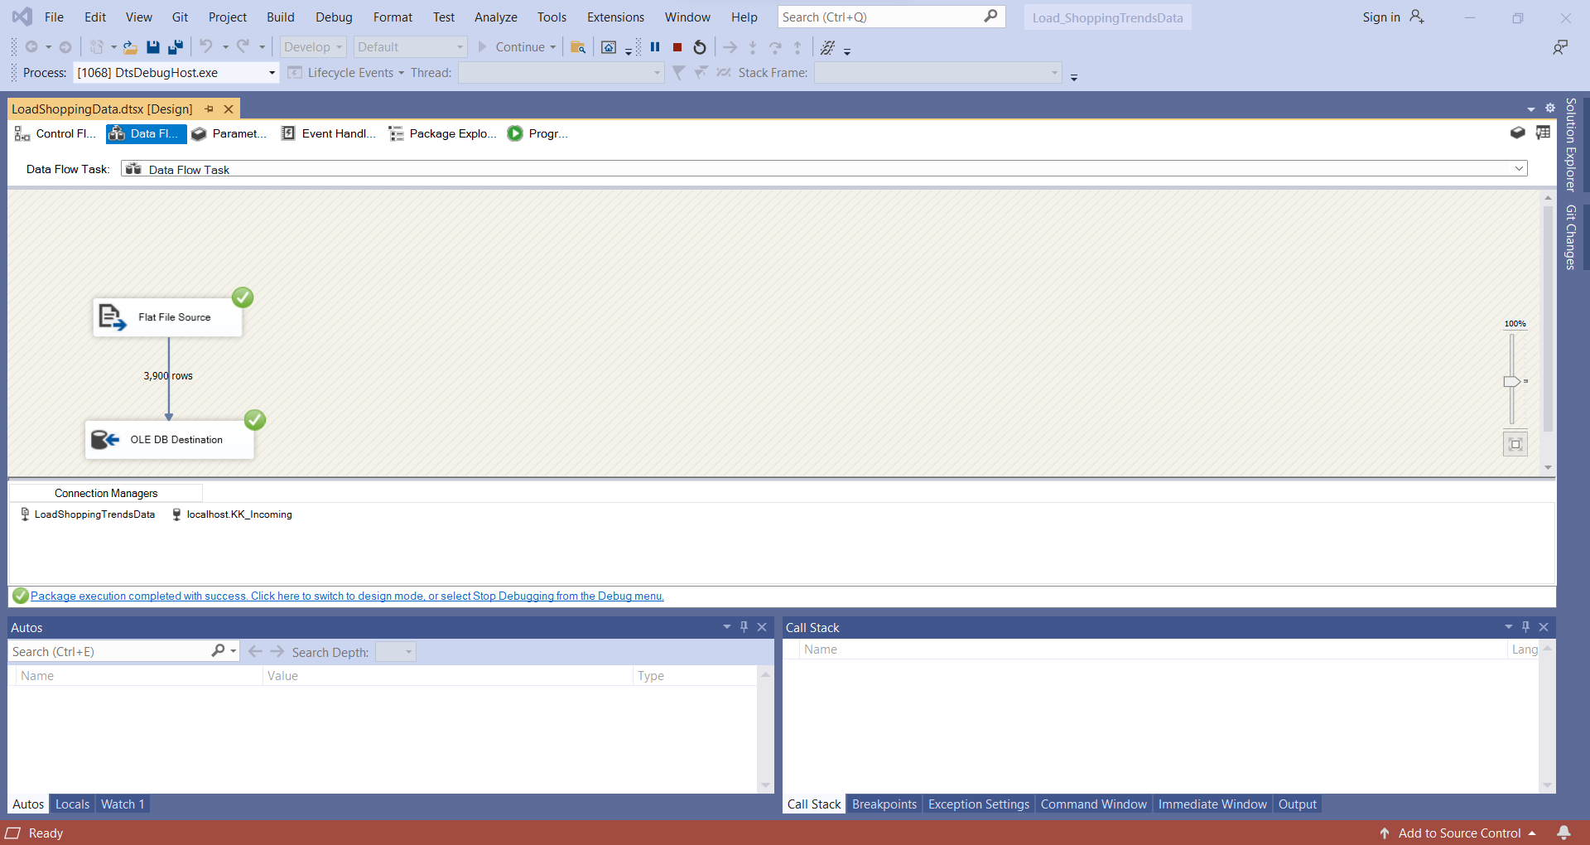

1. Now let’s query the table and see if the data is loaded.

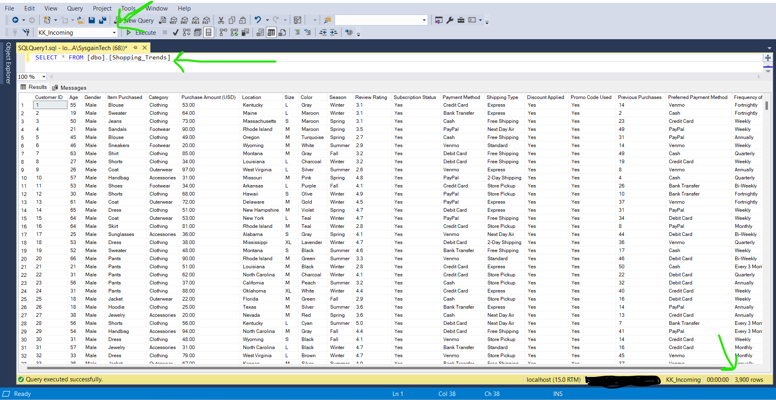

We have successfully loaded CSV data into Database table.

You can find the complete solution and SSIS package in my GITHUB repository.